b1 FROM BASE 16 TO BASE 10

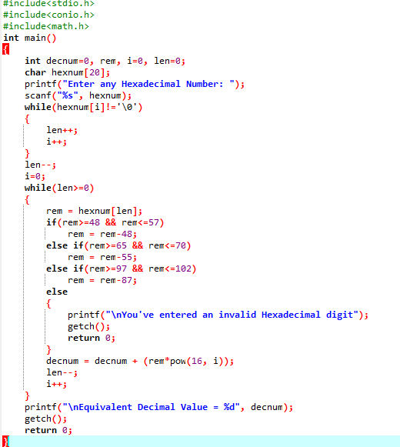

OUTPUT

